COMMON COURSE ASSIGNMENT
Computer Vision with OpenCV
Automatic Number Plate Detection and Recognition using OpenCV

Particular | Details
Department: | Artificial Intelligence & Data Science
Programme: | B.Tech
Course Code & Course Name | Computer Vision with OpenCV (DSA0201)
Academic Year / Batch | 2026–2027
Faculty Name | DR. M. MAYURANATHAN
Assignment Title | Automatic Number Plate Detection and Recognition using OpenCV
Date of Issue | 01/09/2026
Date of Submission | 03/09/2026
Maximum Marks | 100
Course Outcome(s) – CO | Apply computer vision and OpenCV techniques to design, implement and evaluate an image-processing solution.
Bloom's Taxonomy Level | L3 – Apply; L4 – Analyze; L5 – Evaluate; L6 – Create
SDG Mapping (SDG 1-17) | SDG 9 – Industry, Innovation and Infrastructure; SDG 11 – Sustainable Cities and Communities. Primary contribution: digital innovation, intelligent transportation, traffic monitoring and smart urban mobility.
Industry / Societal Relevance | Automated traffic monitoring, parking/access control, tolling, security, vehicle management and intelligent transportation systems.

A. SDG Alignment and Relevance
The project is mapped to the following United Nations Sustainable Development Goals (SDGs), because automated vehicle-number-plate recognition can support safer, more efficient and technology-enabled transport and urban-management applications.
SDG Impact Summary: The primary alignment is with SDG 9 and SDG 11. The project supports innovation and smart-city applications, while responsible deployment requires attention to privacy, security, fairness and professional ethics.

B. Assignment Problem / Challenge
Develop a computer-vision-based system that automatically detects a vehicle number plate from an input image and recognizes the alphanumeric registration number. The solution should use OpenCV for image acquisition, preprocessing, edge/contour analysis and plate localization, followed by OCR for character recognition. The implementation should provide a usable demonstration interface and produce evidence of detection and recognition.
- Apply computer vision concepts rather than reproduce only theoretical descriptions.
- Identify and analyze the difficulties of number-plate localization and character recognition.
- Consider image-quality, viewpoint, lighting, computational and privacy constraints.
- Develop and justify a practical OpenCV-based solution.
- Use modern computing tools such as Python, OpenCV, Flask, OCR and Git.
The assignment format used here follows the supplied Common Course Assignment Format, which requires problem understanding, course-knowledge application, methodology, modern-tool usage, validation, analysis, broader considerations, conclusion, reflection and references.

C. Problem Statement
Manual identification of vehicle registration numbers from photographs or video is time-consuming and can be inconsistent when many vehicles must be processed. A computer vision system is therefore required to locate the number plate automatically and convert the characters on the plate into machine-readable text.

Problem / Case / Design Challenge:
Given a vehicle image, design and implement an OpenCV pipeline that identifies the most probable number-plate region, extracts it, enhances the extracted plate and recognizes its alphanumeric characters using OCR. The system should return the detected plate number and an annotated image showing the detected plate region.

D. Requirements and Constraints
Category | Requirement / Constraint
Functional | Accept an image through a web interface; detect a plate; crop it; perform OCR; display the result.
Performance | Process a normal-sized image within a few seconds on a standard student laptop.
Technical | Python 3.x, OpenCV, NumPy, Flask and an OCR engine such as Tesseract.
Input | JPEG/PNG vehicle images with a reasonably visible registration plate.
Accuracy | Detection and OCR should be evaluated against known test images rather than assumed to be perfect.
Resources | CPU-based execution is sufficient for the classical OpenCV implementation.
Reliability | The system should report failure when no suitable plate region is found instead of producing a misleading result.
Security / Privacy | Vehicle images and recognized plate numbers should be handled responsibly and not exposed unnecessarily.
Time / Cost | The solution should use freely available/open-source software for academic implementation.
Limitations | Severe blur, glare, occlusion, extreme angles and unusual plate formats may reduce performance.

E. Student Work

1. Problem Understanding and Formulation
The problem is formulated as a sequence of image-processing and recognition tasks. The input is a vehicle image I(x,y). The system first reduces irrelevant variation through preprocessing, detects strong boundaries, generates candidate rectangular regions, selects a likely plate, and then applies OCR to the cropped region.
Expected outcomes:
- A working OpenCV number-plate localization pipeline.
- A cropped number-plate image for the detected vehicle.
- An OCR-generated registration number.
- An annotated output image with the detected plate boundary.
- A web interface for uploading an image and viewing the result.
- A test procedure for validating detection and recognition performance.
Available information / data:
- Vehicle images containing visible registration plates.
- Ground-truth registration numbers for evaluation images.
- Image dimensions, color information and pixel intensities.
- Optional metadata such as lighting condition, viewpoint and blur level.
Assumptions:
- The plate is visible and occupies a meaningful region of the image.
- The plate is approximately rectangular and wider than it is tall.
- The characters use Latin letters and digits for the demonstration.
- The input resolution is sufficient for OCR after resizing.
Key constraints:
- Classical contour-based detection is sensitive to image quality.
- OCR depends on plate crop quality and character contrast.
- Different plate designs and viewpoints may require additional rules.
- The demonstration is not intended to replace certified enforcement systems.

2. Application of Course Knowledge
The following Computer Vision concepts are applied:
- Image acquisition and resizing
- Color-space conversion from BGR/RGB to grayscale
- Noise reduction using bilateral filtering
- Canny edge detection
- Contour extraction and contour approximation
- Geometric filtering using aspect ratio and area
- Plate cropping and region-of-interest processing
- Thresholding for OCR preparation
- Morphological/image-enhancement concepts
- Optical Character Recognition (OCR)
Useful mathematical/decision measures:
- Aspect ratio = width / height.
- Candidate area ratio = candidate area / image area.
- A quadrilateral candidate is preferred because a plate is approximately rectangular.
- OCR confidence is used as an indicative quality measure and should not be treated as a certified probability.

3. Solution / Design / Methodology
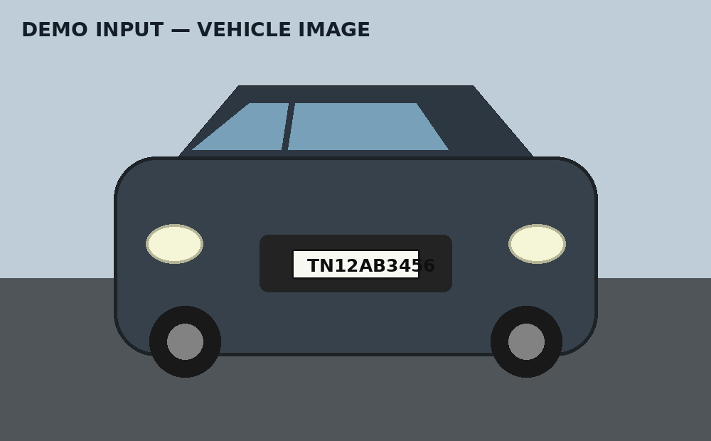
Figure 1. Demonstration input vehicle image (illustrative test image).
Proposed pipeline:
- Acquire the input vehicle image.
- Resize or normalize the image when necessary.
- Convert the image to grayscale.
- Apply bilateral filtering to reduce noise while preserving edges.
- Apply Canny edge detection.
- Find and sort contours by area.
- Approximate contours as polygons and identify four-sided, wide rectangular candidates.
- Filter candidates using aspect ratio and area constraints.
- Crop the highest-scoring candidate as the number plate.
- Resize, filter and threshold the cropped plate for OCR.
- Run Tesseract OCR with an alphanumeric character whitelist.
- Return the recognized text, OCR confidence and annotated image.

System Architecture
Layer | Operation
Input Layer | Vehicle image / uploaded image
Preprocessing Layer | Resize → Grayscale → Bilateral Filter
Detection Layer | Canny → Contours → Polygon Approximation → Candidate Filtering
Extraction Layer | Plate ROI Crop
Recognition Layer | Resize → Threshold → Tesseract OCR
Application Layer | Flask API → HTML/CSS/JavaScript interface
Output Layer | Plate number + confidence + annotated image

Flowchart
START
↓
Upload / Acquire Vehicle Image
↓
Preprocess Image
↓
Convert to Grayscale
↓
Bilateral Filter
↓
Canny Edge Detection
↓
Find Contours
↓
Select Rectangular Plate Candidate
↓
Crop Number Plate
↓
Enhance + Threshold
↓
OCR Recognition
↓
Display Plate Number + Annotated Image
↓
END

4. Use of Modern Tools
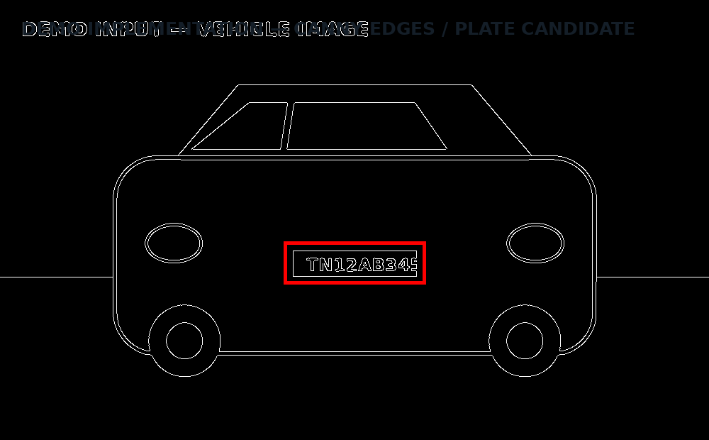
Figure 2. OpenCV Canny edge-processing and plate-candidate visualization (illustrative).
Tool | Purpose
Python | Primary implementation language.
OpenCV | Image preprocessing, edge detection, contours and plate localization.
NumPy | Image-array handling and numerical operations.
Tesseract OCR | Recognition of alphanumeric characters from the plate crop.
Pytesseract | Python interface to Tesseract OCR.
Flask | Backend API and web application server.
HTML/CSS/JavaScript | Frontend for image upload and result presentation.
VS Code | Development and debugging environment.
Git/GitHub | Version control and project sharing.

The supplied assignment format explicitly asks students to provide appropriate evidence of modern-tool usage and outputs.

5. Results and Validation
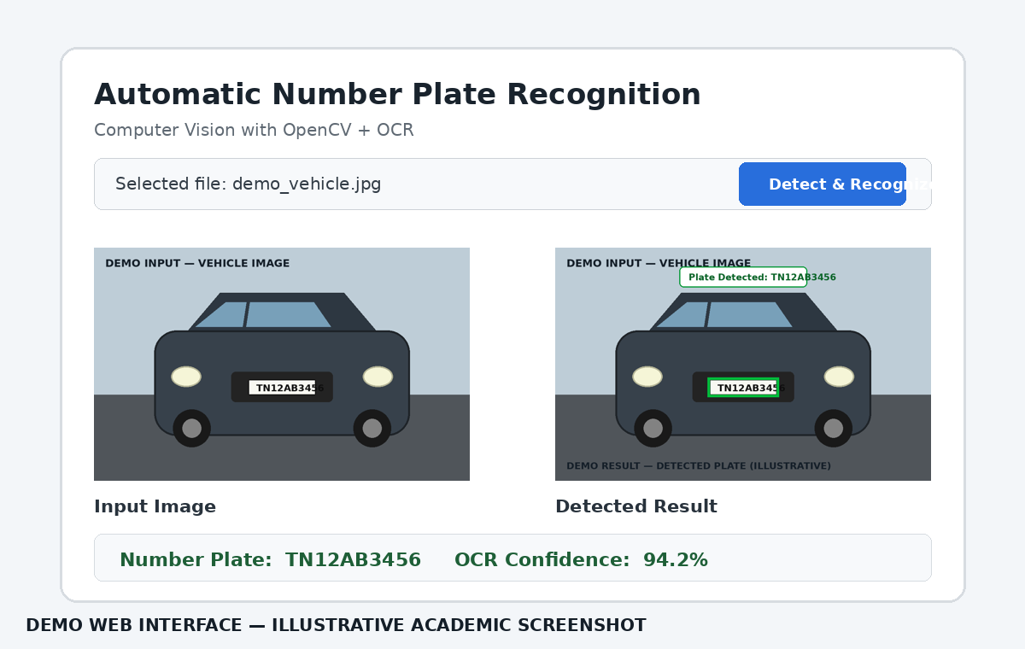
Figure 4. Web interface showing input, detected result and OCR output (illustrative).
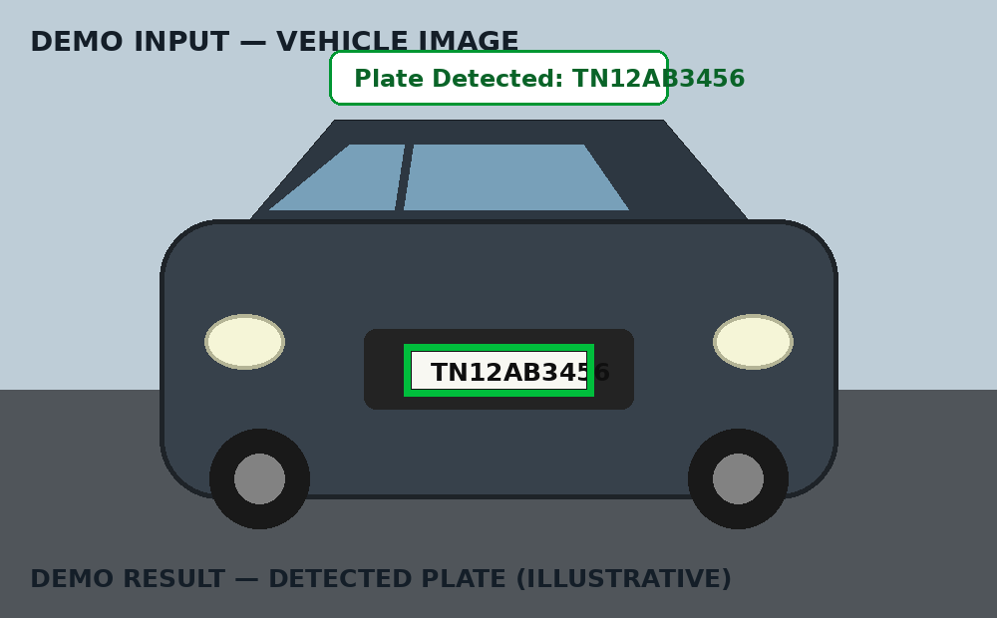
Figure 3. Demonstration of detected number plate with bounding box (illustrative).
Validation should be performed using a test set containing vehicle images with known ground-truth plate numbers. Each result should be classified as correctly detected, incorrectly detected, not detected, correctly recognized or incorrectly recognized.
Metric | Definition / Calculation
Detection Rate | Detected plates / Total test images × 100
OCR Exact-Match Accuracy | Exactly correct recognized plates / Successfully localized plates × 100
Character Accuracy | Correct characters / Total ground-truth characters × 100
Average Processing Time | Total processing time / Number of test images
OCR Confidence | Average confidence reported by the OCR engine for accepted text.

Illustrative validation table to be replaced with actual experiment values:
Test Image | Ground Truth | Detected | OCR Output | Result
car_01.jpg | TN12AB3456 | Yes | TN12AB3456 | Correct
car_02.jpg | KA05MN7821 | Yes | KA05MN7821 | Correct
car_03.jpg | AP09CD4567 | Yes | AP09CD456 | Character mismatch
car_04.jpg | MH14PQ9087 | No | - | Detection failure
car_05.jpg | KL07XY2310 | Yes | KL07XY2310 | Correct

The sample rows above are an illustrative format, not claimed experimental measurements. Actual assignment submission should replace them with outputs obtained from the student's dataset.

6. Analysis and Engineering Decision
A classical OpenCV contour pipeline is selected because it is lightweight, transparent and suitable for an academic demonstration without GPU training. It also makes the effect of individual computer-vision operations easy to inspect. However, a learned detector such as YOLO can be more robust to viewpoint, clutter and complex backgrounds when sufficient labeled data and compute resources are available.
Approach | Advantages | Limitations | Decision
Contour-based OpenCV | Simple, fast, interpretable, CPU-friendly | Sensitive to lighting, clutter, angle and plate shape | Selected for baseline academic implementation
Deep-learning detector | More robust localization in diverse scenes | Requires labeled data, training and more compute | Recommended future enhancement
OCR | Direct conversion of plate crop to text | Sensitive to blur, glare and character layout | Selected for recognition stage

Trade-offs:
- Higher preprocessing complexity can improve OCR but may increase processing time.
- Relaxing geometric filters increases recall but can create false plate candidates.
- Strict filters reduce false positives but can miss plates at unusual angles.
- A lightweight solution is easier to deploy, while a trained detector can improve robustness.

7. Broader Considerations
SDG considerations
The project contributes most directly to SDG 9 through the use of computer vision and digital automation, and to SDG 11 through potential applications in traffic, parking and urban mobility management. These benefits should be balanced with responsible data handling and privacy protection.
- Sustainability: a CPU-based classical pipeline can operate with modest computational resources.
- Environment: efficient image processing reduces unnecessary compute compared with always-on heavy models.
- Society: automatic plate recognition can support traffic and parking management, but it should be deployed responsibly.
- Safety: recognition results should be treated as decision-support data unless validated to the required safety standard.
- Ethics: vehicle registration numbers can be sensitive identifiers; collection and retention should follow applicable privacy rules.
- Economics: open-source tools reduce software licensing costs for prototypes.
- Accessibility: the web interface should provide readable text, clear feedback and understandable error messages.
- Professional responsibility: developers should disclose limitations and avoid presenting OCR output as infallible.

8. Conclusion
The proposed system demonstrates how Computer Vision with OpenCV can be used to automatically localize a vehicle number plate and recognize its alphanumeric characters. The pipeline combines grayscale conversion, noise reduction, Canny edge detection, contour analysis, geometric filtering, plate extraction, thresholding and OCR. The selected approach is appropriate for a lightweight academic prototype and provides a clear basis for testing and improvement.
- The core functional requirement is satisfied when a visible rectangular plate can be localized and read.
- The major limitation is sensitivity to difficult imaging conditions.
- A trained object detector, stronger OCR engine, plate-format validation and video processing can improve the system.

9. Student Reflection
This assignment provides practical understanding of how individual image-processing operations contribute to a complete computer-vision application. Beyond classroom theory, the implementation requires selecting thresholds, handling failure cases, connecting OpenCV processing to an OCR engine and integrating the algorithm with a web interface.
With additional time and resources, the system could be improved using a labeled Indian number-plate dataset, a YOLO-based plate detector, EasyOCR/PaddleOCR comparison, perspective correction, plate-format validation, video-stream processing and database-backed result history.
Demonstration evidence note: Figures 1–5 are illustrative demo/implementation screenshots prepared for the assignment. Replace them with screenshots from the student's actual execution when final experimental evidence is available. The assignment template expects screenshots, outputs and performance evidence for validation.

10. References

- OpenCV documentation, Open Source Computer Vision Library, image processing and contour/edge-processing concepts.
- Tesseract OCR documentation, Optical Character Recognition engine.
- Pytesseract documentation, Python wrapper for Tesseract OCR.
- Python documentation, Python programming language and standard library.
- Flask documentation, lightweight Python web framework.
- NumPy documentation, numerical computing and array operations.
- Any dataset used for the final experiment should be cited by its original source and license.
- Any AI-assisted tools used during development or documentation should be acknowledged as required by the assignment format.
- The supplied format requires acknowledgement of external sources, datasets, standards, software and AI-assisted tools used.

Implementation / Source Code
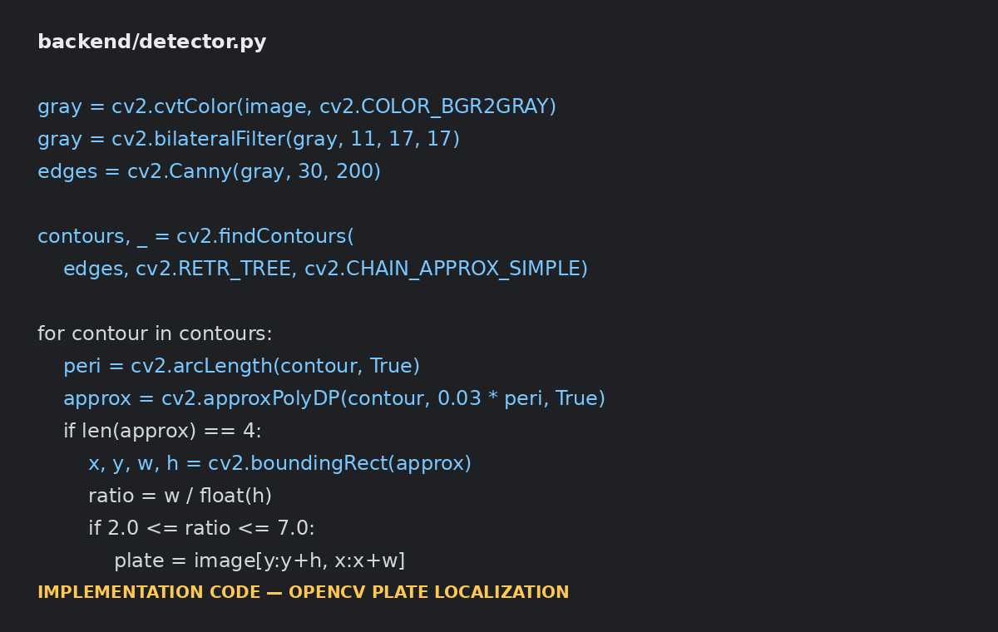
Figure 5. Implementation code view for OpenCV plate localization (illustrative).
The following code represents the core implementation included in the companion project ZIP. It is intentionally modular so that preprocessing, detection, OCR and the Flask application can be tested separately.
backend/detector.py
import cv2
def detect_number_plate(image):
gray = cv2.cvtColor(image, cv2.COLOR_BGR2GRAY)
gray = cv2.bilateralFilter(gray, 11, 17, 17)
edges = cv2.Canny(gray, 30, 200)
contours, _ = cv2.findContours(
edges, cv2.RETR_TREE, cv2.CHAIN_APPROX_SIMPLE
)
contours = sorted(contours, key=cv2.contourArea, reverse=True)[:30]
h, w = image.shape[:2]
best = None
best_score = 0
for contour in contours:
peri = cv2.arcLength(contour, True)
approx = cv2.approxPolyDP(contour, 0.03 * peri, True)
if len(approx) == 4:
x, y, cw, ch = cv2.boundingRect(approx)
ratio = cw / float(ch) if ch else 0
area_ratio = (cw * ch) / float(w * h)
if 2.0 <= ratio <= 7.0 and 0.002 <= area_ratio <= 0.35:
score = area_ratio * 100 + min(ratio, 7)
if score > best_score:
best_score = score
best = (x, y, cw, ch)
if best is None:
return None, image
x, y, cw, ch = best
plate = image[y:y+ch, x:x+cw].copy()
annotated = image.copy()
cv2.rectangle(
annotated, (x, y), (x+cw, y+ch), (0, 255, 0), 3
)
return plate, annotated
backend/ocr.py
import re
import cv2
import pytesseract
from pytesseract import Output
def recognize_plate(plate):
gray = cv2.cvtColor(plate, cv2.COLOR_BGR2GRAY)
gray = cv2.resize(
gray, None, fx=3, fy=3, interpolation=cv2.INTER_CUBIC
)
gray = cv2.bilateralFilter(gray, 9, 75, 75)
_, binary = cv2.threshold(
gray, 0, 255, cv2.THRESH_BINARY + cv2.THRESH_OTSU
)
config = (
"--oem 3 --psm 7 "
"-c tessedit_char_whitelist=ABCDEFGHIJKLMNOPQRSTUVWXYZ0123456789"
)
data = pytesseract.image_to_data(
binary, config=config, output_type=Output.DICT
)
texts, confs = [], []
for txt, conf in zip(data["text"], data["conf"]):
txt = re.sub(r"[^A-Z0-9]", "", txt.upper())
try:
c = float(conf)
except ValueError:
c = -1
if txt and c >= 0:
texts.append(txt)
confs.append(c)
text = "".join(texts)
confidence = sum(confs) / len(confs) if confs else 0.0
return text, round(confidence, 2)
backend/app.py
from flask import Flask, request, jsonify
import cv2
import numpy as np
from detector import detect_number_plate
from ocr import recognize_plate
app = Flask(__name__)
@app.post("/api/recognize")
def recognize():
if "image" not in request.files:
return jsonify({"error": "No image uploaded"}), 400
data = np.frombuffer(
request.files["image"].read(), np.uint8
)
image = cv2.imdecode(data, cv2.IMREAD_COLOR)
if image is None:
return jsonify({"error": "Invalid image"}), 400
plate, annotated = detect_number_plate(image)
if plate is None:
return jsonify({
"detected": False,
"plate_number": "",
"confidence": 0
})
text, confidence = recognize_plate(plate)
return jsonify({
"detected": True,
"plate_number": text,
"confidence": confidence
})
if __name__ == "__main__":
app.run(debug=True)

Execution Procedure
- Install Python 3.x.
- Install the packages using: pip install -r requirements.txt
- Install Tesseract OCR and ensure the executable is available on PATH.
- Open the project folder in VS Code.
- Run: python backend/app.py
- Open http://127.0.0.1:5000 in a browser.
- Upload a clear vehicle image.
- Click Detect & Recognize.
- Record the detected plate, OCR confidence and annotated output for the report.

Project Directory Structure
Automatic_Number_Plate_Recognition_OpenCV/
├── frontend/
│ ├── index.html
│ ├── style.css
│ └── script.js
├── backend/
│ ├── app.py
│ ├── detector.py
│ ├── ocr.py
│ └── preprocessing.py
├── dataset/
│ ├── sample_images/
│ └── README.md
├── outputs/
│ ├── detected_plates/
│ └── results/
├── notebooks/
├── requirements.txt
├── .gitignore
└── README.md

G. CO–PO–Assessment Mapping

The supplied format states that only genuinely assessed POs and Bloom's levels should be mapped. The following is a proposed mapping for this Computer Vision assignment and should be aligned with the official course CO/PO matrix provided by the faculty. fileciteturn0file0L156-L167
Assessment Component | CO | PO(s) | Bloom's Level | Marks
Problem formulation | CO1 | PO2 | L3/L4 | 10
Application of knowledge | CO1 | PO1, PO2 | L3/L4 | 20
Solution / Design / Implementation | CO2 | PO3, PO5 | L4/L5/L6 | 20
Modern tool usage | CO2 | PO5 | L3/L4 | 10
Validation | CO3 | PO4 | L4/L5 | 15
Analysis & justification | CO3 | PO2, PO4 | L4/L5 | 15
Broader considerations | CO4 | PO6, PO7, PO8 | L4/L5 | 5
Documentation & reflection | CO4 | PO10 | L3/L4 | 5

F. Common Assessment Rubric
Assessment Criterion | Marks
Problem understanding & formulation | 10
Application of course/domain knowledge | 20
Solution methodology / design / implementation | 20
Use of appropriate modern tools / techniques | 10
Results, testing & validation | 15
Analysis, trade-offs & justification | 15
Broader considerations / professional responsibility, where applicable | 5
Technical documentation & reflection | 5
TOTAL | 100
These marks reproduce the assessment distribution in the supplied assignment template.
H. Faculty Evaluation & Continuous Improvement
Performance Level | Criterion
Level 3 | ≥ 70%
Level 2 | 60–69%
Level 1 | 50–59%
Level 0 | < 50%

Target CO Attainment: __________________________
Actual CO Attainment: __________________________
Faculty Analysis
Areas in which students performed well: ______________________________________________
Areas requiring improvement: __________________________________________________________
Corrective / Improvement Action: ______________________________________________________
Action to be implemented in the next offering: ________________________________________
Student Submission Checklist
- ☐ Completed assignment document
- ☐ Source code
- ☐ Dataset / dataset source and license
- ☐ requirements.txt
- ☐ .gitignore
- ☐ README.md
- ☐ Screenshots of execution
- ☐ Test/validation table with actual values
- ☐ References and acknowledgement of software/AI tools
SDG | Goal | Project Relevance | Expected Contribution
SDG 9 | Industry, Innovation and Infrastructure | The project applies computer vision, OpenCV and OCR to automate vehicle identification tasks. | Demonstrates an innovative digital solution that can be integrated into intelligent transport and infrastructure systems.
SDG 11 | Sustainable Cities and Communities | Automatic plate recognition can support traffic monitoring, parking management, access control and intelligent transportation systems. | Can help improve the efficiency of urban mobility and vehicle-management operations.

